**Module 4: Where You Live and Work**

[INTROM4] The questions in this section are about places where you have lived and worked. Where we live and our daily commute to and from our homes, work, and school can affect our health in a number of ways.

**Residential History [SECTION 1]**

[INTRORH] The next questions ask about where you live now and where you have lived in the past. It is important that you share exact addresses, if possible. If you cannot remember your full address, please share as much information as you can.

You can include rural routes (RR) in your answers, but please do **not** include post office (PO) boxes.

1. [HOMEADD1] **(*IF 1ST TIME THROUGH LOOP*)** What is the full street address of the place where you live now?

**(*IF 2ND – 11TH TIME THROUGH LOOP*)** What is the full street address of the place you lived before you lived at **(Insert previous address in loop)**? Please only include addresses where you have lived for **at least two years.**

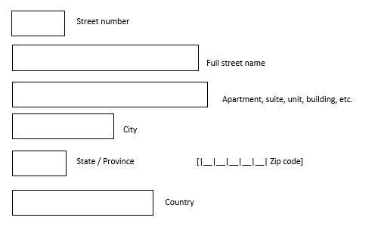

*NO RESPONSE à* ***GO TO HOMEADD2***

**Instructions for HOMEADD2:**

**[IF RESPONDENT LEAVES ALL FIELDS BLANK IN HOMEADD1, PROMPT WITH BELOW. IF RESPONDENT LEAVES CITY, STATE, ZIP, OR COUNTRY BLANK IN HOMEADD1, PROMPT WITH BELOW.]**

**[NOTE FOR PROGRAMMERS: ONLY FIELDS THAT WERE NOT ALREADY COMPLETED IN HOMEADD1 SHOULD BE PRESENTED AS OPEN FIELDS. IF RESPONSE WAS ALREADY PROVIDED TO ANY OF THESE FIELDS IN HOMEADD1, POPULATE THE FIELD(S) AS PROTECTED, SUMMARIZED INFORMATION IN HOMEADD2]**

1. [HOMEADD2] Please provide the following information:

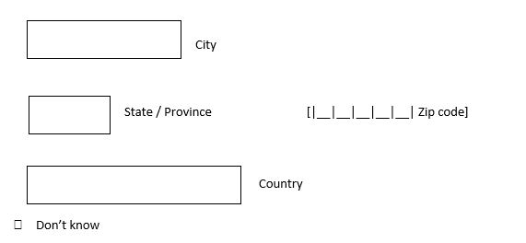

**Instructions for HOMEADD3:**

**[IF RESPONDENT LEAVES STREET NUMBER AND STREET NAME BLANK IN HOMEADD1 BUT COMPLETED THE CITY, STATE, ZIP, AND/OR COUNTRY FIELDS IN HOMEADD1 AND/OR HOMEADD2, PROMPT WITH BELOW. IF ALL FIELDS LEFT BLANK IN HOMEADD1 AND HOMEADD2, SKIP TO HOMEADD4.]**

1. [HOMEADD3] Please provide the cross streets of the intersection closest to this address:

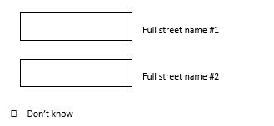

*NO RESPONSE à* ***GO TO HOMEADD4***

**[REPEAT HOMEADD4 AND HOMEADDOTH UNTIL RESPONDENT SELECTS NO AT HOMEADDOTH. SHOW HOMEADD1 – HOMEADD3 UP TO 11 TIMES]**

**[PIPED TEXT SHOULD INCLUDE ALL ADDRESS DETAILS THAT WERE PROVIDED. IF NO ADDRESS DETAILS WERE PROVIDED, FILL “current address”, “the 2nd address you provided”, “the 3rd address you provided”, etc.]**

1. [HOMEADD4] Here is the information you gave us for this location: [Insert address information from HOMEADD1 – HOMEADD3]

If this information is **not** correct, please click the “Back” button to edit your answers before moving on.

**[IF 11TH TIME AT HOMEADD4, GO TO HOMEADDSUM]**

1. [HOMEADDOTH] Within the **past 20 years,** have you lived anywhere else for at least **two years**?
2. Yes à **GO TO HOMEADD1**

0 No à **GO TO HOMEADDSUM**

*NO RESPONSE* à***GO TO HOMEADDSUM***

**[PIPED TEXT SHOULD INCLUDE ALL ADDRESS DETAILS THAT WERE PROVIDED. IF NO ADDRESS DETAILS WERE PROVIDED, FILL “current address”, “the 2nd address you provided”, “the 3rd address you provided”, etc.]**

**[NOTE: THIS IS PROGRAMMED ITERATIVELY, NOT AS A LOOP, BUT DOCUMENTATION SHOWS LOOP FOR VIEWING SIMPLICITY]**

1. [HOMEADDSUM, HOMEADDSUM_2, HOMEADDSUM_3 . . . HOMEADDSUM_10]

**[DISPLAY IF 1ST – 10TH TIME THROUGH LOOP]**

Please review the list below and tell us if it includes all of the addresses where you have lived for at least two years in the last 20 years.

Once you move on from this screen, you will **not** be able to add another address or edit your answers.

If you would like to add another address or edit your answers, please select "No, I want to add another address."

[INSERT LIST OF ADDRESSES COLLECTED IN HOMEADD1 – HOMEADD3 IN ORDER THAT THEY WERE SUBMITTED]

0 Yes, this list is complete **[DISPLAY IF 1ST – 10TH TIME THROUGH LOOP]** à **GO TO**

**HOMEMOVEIN**

1 No, I want to add another address **[DISPLAY IF 1ST – 10TH TIME THROUGH LOOP]** à **GO**  **TO HOMEADD1**

*NO RESPONSE* à***GO TO HOMEMOVEIN***

**[HOMEADDSUM_11] [DISPLAY IF 11TH TIME THROUGH LOOP]**

***[NOTE TO PROGRAMMERS: THE FOLLOWING QUESTION TEXT GOES ABOVE THE ADDRESS LIST]***Thank you for your responses. You have entered the maximum number of addresses. You will proceed to the next questions.

[INSERT LIST OF ADDRESSES COLLECTED IN HOMEADD1 – HOMEADD3 IN ORDER THAT THEY WERE SUBMITTED]

**[ASK HOMEMOVEIN – HOMEMOVE OUT FOR EACH ADDRESS PROVIDED IN HOMEADD1 – HOMEADD3.]**

**[PIPED TEXT SHOULD INCLUDE ALL ADDRESS DETAILS THAT WERE PROVIDED. IF NO ADDRESS DETAILS WERE PROVIDED, FILL “current address”, “the 2nd address you provided”, “the 3rd address you provided”, etc.]**

1. [HOMEMOVEIN] What year did you move into **[insert address from HOMEADD1 – HOMEADD3/current address/the 2nd address you provided/etc.]**?

|__|__|__|__| Year moved in

*NO RESPONSE* à***GO TO HOMEMOVEOUT***

1. [HOMEMOVEOUT] What year did you move out of [insert address from HOMEADD1 – HOMEADD3/ current address/the 2nd address you provided/etc.]? If you still live at this address, select “I still live here.”

|__|__|__|__| Year moved out

0 I still live here

*NO RESPONSE* à ***IF LAST ADDRESS PROVIDED,******GO TO INTROHOMEWTR. IF NOT LAST ADDRESS PROVIDED, REPEAT HOMEMOVEIN – HOMEMOVEOUT FOR EACH ADDRESS PROVIDED.***

[INTROHOMEWTR] The next questions ask about your water usage at each of the addresses you provided.

**[ASK HOMEWTR1 – HOMEWTR3 FOR EACH ADDRESS PROVIDED IN HOMEADD1 – HOMEADD3.]**

**[PIPED TEXT SHOULD INCLUDE ALL ADDRESS DETAILS THAT WERE PROVIDED. IF NO ADDRESS DETAILS WERE PROVIDED, FILL “current address”, “the 2nd address you provided”, “the 3rd address you provided”, etc.]**

**[IF ASKING ABOUT 1ST ADDRESS COLLECTED IN HOMEADDLOOP, fill “is”;**

**IF ASKING ABOUT 2ND - 11TH ADDRESS COLLECTED IN HOMEADDLOOP, fill “was”]**

1. [HOMEWTR1] What [is/was]the source of water to [insert address from HOMEADD1 – HOMEADD3/ current address/the 2nd address you provided/etc.]?
2. A public or municipal water supply **à GO TO HOMEWTR3**

1 A rural water system, community well, or spring serving at least 25 people or 15 households **à GO TO HOMEWTR3**

2 Private well or spring

55 Other: Please describe [text box] **à GO TO HOMEWTR3**

77 Don’t know **à GO TO HOMEWTR3**

*NO RESPONSE* à***GO TO HOMEWTR3***

**[IF ASKING ABOUT 1ST ADDRESS COLLECTED IN HOMEADDLOOP, fill “is”**

**IF ASKING ABOUT 2ND - 11TH ADDRESS COLLECTED IN HOMEADDLOOP, fill “was”]**

1. [HOMEWTR2] About how deep [is/was] your private well?
2. Less than 50 feet

1 50 to 100 feet

2 101 to 150 feet

3 151 to 250 feet

4 251 to 500 feet

5 More than 500 feet

77 Don’t know

*NO RESPONSE* à***GO TO HOMEWTR3***

**[IF ASKING ABOUT 1ST ADDRESS COLLECTED IN HOMEADDLOOP, fill “is”, “drink”, and “drink”;**

**IF ASKING ABOUT 2ND - 11TH ADDRESS COLLECTED IN HOMEADDLOOP, fill “was”, “drank”, and “have drunk”]**

1. [HOMEWTR3] What [is/was] the main source of water that you [drink/drank] at [insert address from HOMEADD1 – HOMEADD3/current address/the 2nd address you provided/etc.]? Please think about water you used to make drinks such as coffee and tea, and plain water that you [drink/drank].
2. Water from the tap or refrigerator that has **not** been filtered or treated

1 Water from a refrigerator that has a water filter

2 Water that was filtered using a filter like Brita ® or PUR ® in a pitcher or on a faucet

3 Water that was filtered using reverse osmosis (under sink or whole house)

4 Water that was filtered with another type of filter (under sink or whole house)

5 Bottled water, including water from a store dispenser or delivered to your home

55 Other: Please describe [text box]

77 Don’t know

*NO RESPONSE*

**FOR ALL RESPONSE OPTIONS: *IF LAST ADDRESS PROVIDED, GO TO INTROSH. IF NOT LAST ADDRESS PROVIDED, REPEAT HOMEWTR1 – HOMEWTR3 FOR EACH ADDRESS PROVIDED.***

***[NOTE: THIS IS WRITTEN AS A LOOP, BUT THE PROGRAMMING WAS DONE ITERATIVELY]***

*[Informational text to accompany the first response category above: Please only include water that has not been filtered or treated through reverse osmosis, distillation, or filters that remove lead, chlorine, pesticides, or other chemicals. You can include water filtered with water softeners, which are filters that remove only sediment from the water.]*

**Seasonal Homes**

[INTROSH] We are interested in the time you have spent in seasonal or vacation homes. We want to know about any homes where you have spent at least 24 months in the past 20 years (that is, since [CURRENT YEAR – 20]). Living somewhere for a few months each year counts if the total time you have spent there adds up to at least 24 months.

1. [SEASHOME] In the **past 20 years**, have you spent a **total of 24 months or more** in a seasonal or vacation home in the U.S.?

1 Yes

0 No à **GO TO SEASADDSUM1**

*NO RESPONSE* à***GO TO CHILDADD***

**[DISPLAY IF SEASHOME = 00] [NOTE: SEASADDSUM1 is only shown to those that respond SEASHOME=0 (and it’s directly after SEASHOME)]**

1. [SEASADDSUM1]You told us that you have not spent a total of 24 months or more at any seasonal or vacation homes in the past 20 years. Is this correct?

Once you move on from this screen, you will **not** be able to return to these questions to add any seasonal or vacation home addresses. If you would like to add a seasonal or vacation home address, please select "No, I want to add a seasonal or vacation home address."

1 Yes, this is correct à **GO TO CHILDADD**

0 No, I want to add a seasonal or vacation home address à **GO TO SEASADD1**

*NO RESPONSE* à***GO TO CHILDADD***

1. [SEASADD1] What is the full street address of your seasonal or vacation home?



*NO RESPONSE* à***GO TO SEASADD2***

**Instructions for SEASADD2:**

**[IF RESPONDENT LEAVES ALL FIELDS BLANK IN SEASADD1, PROMPT WITH BELOW. IF RESPONDENT LEAVES CITY, STATE, OR ZIP BLANK IN SEASADD1, PROMPT WITH BELOW.]**

**[NOTE FOR PROGRAMMERS: ONLY FIELDS THAT WERE NOT ALREADY COMPLETED IN SEASADD1 SHOULD BE PRESENTED AS OPEN FIELDS. IF RESPONSE WAS ALREADY PROVIDED TO ANY OF THESE THREE FIELDS IN SEASADD1, POPULATE THE FIELD(S) AS PROTECTED, SUMMARIZED INFORMATION IN SEASADD2]**

1. [SEASADD2] Please provide the following information:



**Instructions for SEASADD3:**

**[IF RESPONDENT LEAVES STREET NUMBER AND STREET NAME BLANK IN SEASADD1 BUT COMPLETED THE CITY, STATE, AND/OR ZIP FIELDS IN SEASADD1 AND/OR SEASADD2, PROMPT WITH BELOW. IF ALL FIELDS LEFT BLANK IN SEASADD1 AND SEASADD2, SKIP TO SEASADD4.]**

1. [SEASADD3] Please provide the cross streets of the intersection closest to this address:



*NO RESPONSE* à***GO TO SEASADD4***

**[PIPED TEXT SHOULD INCLUDE ALL ADDRESS DETAILS THAT WERE PROVIDED. IF NO ADDRESS DETAILS WERE PROVIDED, FILL “the 1st address you provided”, “the 2nd address you provided”, etc.]**

1. [SEASADD4] Here is the information you gave us for this location: [Insert address information from SEASADD1 – SEASADD3]

If this information is **not** correct, please click the “Back” button to edit your answers before moving on.

**[IF 10TH TIME AT SEASADD4, GO TO SEASADDSUM2]**

**[REPEAT SEASADDOTH UP TO 9 TIMES]**

1. [SEASADDOTH] In the **past 20 years,** have you spent a **total of 24 months or more** in any other seasonal or vacation homes in the U.S.?

1 Yes à **GO TO SEASADD1**

0 No à **GO TO SEASADDSUM2**

*NO RESPONSE* à***GO TO SEASADDSUM2***

**[DISPLAY SEASADDSUM2 IF AT LEAST ONE ADDRESS PROVIDED IN SEASADD1 – SEASADD3]**

**[REPEAT SEASADDSUM2 UP TO 10 TIMES]**

**[PIPED TEXT SHOULD INCLUDE ALL ADDRESS DETAILS THAT WERE PROVIDED. IF NO ADDRESS DETAILS WERE PROVIDED, FILL “the 1st address you provided”, “the 2nd address you provided”, etc.]**

1. [SEASADDSUM_1 . . . through SEASADDSUM_10]

**[THIS IS NOT A LOOP, PROGRAMMED ITERATIVELY FOLLOWING SEASADDOTH]**

Please review the list below and tell us if it includes all of the seasonal or vacation home addresses where you have spent a total of 24 months or more in the past 20 years.

Once you move on from this screen, you will **not** be able to add another address or edit your answers.

If you would like to add another seasonal or vacation home address, please select "No, I want to add another seasonal or vacation home address."

[INSERT LIST OF ADDRESSES COLLECTED IN SEASADD1 – SEASADD3 IN ORDER THAT THEY WERE SUBMITTED]

1 Yes, this list is complete **[DISPLAY IF 1ST – 9TH TIME]** à **GO TO**  **SEASADDYRS**

0 No, I want to add another seasonal or vacation home address **[DISPLAY IF 1ST – 9TH**  **TIME ]** à **GO TO SEASADD1**

*NO RESPONSE* à***GO TO SEASADDYRS***

**[DISPLAY IF 10TH TIME]**

***[NOTE TO PROGRAMMERS: THE FOLLOWING QUESTION TEXT GOES ABOVE THE ADDRESS LIST]***Thank you for your responses. You have entered the maximum number of seasonal or vacation home addresses. You will move on to the next questions.

[INSERT LIST OF ADDRESSES COLLECTED IN SEASADD1 – SEASADD3 IN ORDER THAT THEY WERE SUBMITTED]

**[ASK SEASADDYRS – SEASADDMOS FOR EACH SEASONAL HOME ADDRESS PROVIDED IN SEASADD1 – SEASADD3. PIPED TEXT SHOULD INCLUDE ALL ADDRESS DETAILS THAT WERE PROVIDED.]**

**[PIPED TEXT SHOULD INCLUDE ALL ADDRESS DETAILS THAT WERE PROVIDED. IF NO ADDRESS DETAILS WERE PROVIDED, FILL “the 1st address you provided”, “the 2nd address you provided”, etc.]**

1. [SEASADDYRS] What year did you **first** spend time at **[insert address from SEASADD1 – SEASADD3/ the 1st/2nd/3rd/etc. address you provided]**?

|__|__|__|__|Year first spent time at this address

*NO RESPONSE* à***GO TO SEASADDYRS2***

1. [SEASADDYRS2] What year did you **last** spend time at [insert address from SEASADD1 – SEASADD3/ the 1st/2nd/3rd/etc. address you provided]? If you still spend time at this address, select “I still spend time here.”

|__|__|__|__| Year last spent time at this address

0 I still spend time here

*NO RESPONSE* à***GO TO SEASADDMOS***

1. [SEASADDMOS] In general, how many **months per year** did you spend at [insert address from SEASADD1 – SEASADD3/ the 1st/2nd/3rd/etc. address you provided]?

|__|__| months per year

0 Less than 1 month

*NO RESPONSE* à***IF LAST ADDRESS PROVIDED,******GO TO INTROSEASWTR. IF NOT LAST ADDRESS PROVIDED, REPEAT SEASADDYRS - SEASADDMOS FOR EACH ADDRESS PROVIDED.***

[INTROSEASWTR] The next questions ask about your water usage at each of the seasonal or vacation home addresses you provided.

**[ASK SEASWTR1 – SEASWTR3 FOR EACH ADDRESS PROVIDED IN SEASADD1 – SEASADD3.]**

**[PIPED TEXT SHOULD INCLUDE ALL ADDRESS DETAILS THAT WERE PROVIDED. IF NO ADDRESS DETAILS WERE PROVIDED, FILL “the 1st address you provided”, “the 2nd address you provided”, etc.]**

1. [SEASWTR1] What was the source of water to [insert address insert address from SEASADD1 – SEASADD3/ the 1st/2nd/3rd/etc. address you provided]?
2. A public or municipal water supply **à GO TO SEASWTR3**

1 A rural water system, community well, or spring serving at least 25 people or 15 households **à GO TO SEASWTR3**

2 Private well or spring

55 Other: Please describe [text box] **à GO TO SEASWTR3**

77 Don’t know **à GO TO SEASWTR3**

*NO RESPONSE* **à GO TO SEASWTR3**

1. [SEASWTR2] About how deep was your private well?
2. Less than 50 feet

1 50 to 100 feet

2 101 to 150 feet

3 151 to 250 feet

4 251 to 500 feet

5 More than 500 feet

77 Don’t know

*NO RESPONSE* à***GO TO SEASWTR3***

1. [SEASWTR3] What was the main source of water that you drank at [insert address insert address from SEASADD1 – SEASADD3/ the 1st/2nd/3rd/etc. address you provided]? Please think about water you used to make drinks such as coffee and tea, and plain water that you drank.

0 Water from the tap or refrigerator that has **not** been filtered or treated

1 Water from a refrigerator that has a water filter

2 Water that was filtered using a filter like Brita ® or PUR ® in a pitcher or on a faucet

3 Water that was filtered using reverse osmosis (under sink or whole house)

4 Water that was filtered with another type of filter (under sink or whole house)

5 Bottled water, including water from a store dispenser or delivered to your home

55 Other: Please describe [text box]

77 Don’t know

*NO RESPONSE* à***IF LAST ADDRESS PROVIDED,******GO TO CHILDADD. IF NOT LAST ADDRESS PROVIDED, REPEAT SEASWTR1 – SEASWTR3 FOR EACH ADDRESS PROVIDED.***

*[Informational text to accompany the first response category above: Please only include water that has not been filtered or treated through reverse osmosis, distillation, or filters that remove lead, chlorine, pesticides, or other chemicals. You can include water filtered with water softeners, which are filters that remove only sediment from the water.]*

**Childhood Home**

The next questions ask about where you lived as a child.

1. [CHILDADD] What was the street address of your childhood home (where you lived when you were about 13 years old)?

0 I lived at a previous address already entered **à GO TO CHILDTEST**

1 Not listed here **--> GO TO CHILDADD1**

*NO RESPONSE* à***GO TO CHILDADD1***

1. [CHILDTEST] Which previously entered address did you live at when you were about 13 years old?

[Insert list of previously entered residences for participants to select from (from HOMEADD1-HOMEADD3)] **--> GO TO CHILDADD4**

*NO RESPONSE* ***--> GO TO CHILDADD4***

1. [CHILDADD1] If the address of your childhood home was not listed in the previous question, please enter it here. If you cannot remember the full address, please share as much information as you can.



*NO RESPONSE* à***GO TO CHILDADD2***

**[IF RESPONDENT LEAVES ALL FIELDS BLANK IN CHILDADD1, PROMPT WITH BELOW. IF RESPONDENT LEAVES CITY, STATE, ZIP, OR COUNTRY BLANK IN CHILDADD1, PROMPT WITH BELOW.]**

**[NOTE FOR PROGRAMMERS: ONLY FIELDS THAT WERE NOT ALREADY COMPLETED IN CHILDADD1 SHOULD BE PRESENTED AS OPEN FIELDS. IF RESPONSE WAS ALREADY PROVIDED TO ANY OF THESE FIELDS IN CHILDDD1, POPULATE THE FIELD(S) AS PROTECTED, SUMMARIZED INFORMATION IN CHILDADD2]**

1. [CHILDADD2] Please provide the following information:



**[IF RESPONDENT LEAVES STREET NUMBER AND STREET NAME BLANK IN CHILDADD1 BUT COMPLETED THE CITY, STATE, ZIP, AND/OR COUNTRY FIELDS IN CHILDADD1 AND/OR CHILDADD2, PROMPT WITH BELOW. IF ALL FIELDS LEFT BLANK IN CHILDADD1 AND CHILDADD2, SKIP TO CHILDADD4.]**

1. [CHILDADD3] Please provide the cross streets of the intersection closest to this address:



*NO RESPONSE* à***GO TO CHILDADD5***

**[PIPED TEXT SHOULD INCLUDE ALL ADDRESS DETAILS THAT WERE PROVIDED. IF NO ADDRESS DETAILS WERE PROVIDED, FILL “your childhood home”]**

1. [CHILDADD4] Here is the information you gave us for this location: [Insert address information from CHILDADD1 – CHILDADD3]

If this information is **not** correct, please click the “Back” button to edit your answers before moving on.

**[PIPED TEXT SHOULD INCLUDE ALL ADDRESS DETAILS THAT WERE PROVIDED. IF NO ADDRESS DETAILS WERE PROVIDED, FILL “your childhood home”]**

1. [CHILDADD5] What year did you move into **[insert address from CHILDADD1 – CHILDADD3/your childhood home]?**

|__|__|__|__| Year moved in

0 Lived there since birth

77 Don’t know

*NO RESPONSE* à***GO TO CHILDADD6***

1. [CHILDADD6] What year did you move out of [insert address from CHILDADD1 – CHILDADD3/your childhood home]?

|__|__|__|__| Year moved out

0 I still live there

77 Don’t know

*NO RESPONSE* à***GO TO CHILDWTR1***

*[Informational text when “move out” is selected: “If you moved from this home to go to college and did not live here again for more than 6 months at a time, enter the year that you went to college.”]*

1. [CHILDWTR1] What was the source of water to [insert address from CHILDADD1 – CHILDADD3/your childhood home]?

0 A public or municipal water supply

1 A rural water system, community well, or spring serving at least 25 people or 15 households

2 Private well or spring

55 Other: Please describe [text box]

77 Don’t know

*NO RESPONSE* à***GO TO CHILDWTR2***

1. [CHILDWTR2] What was the main source of water that you drank at [insert address from CHILDADD1 – CHILDADD3/your childhood home]? Please think about water used to make drinks such as juice and tea, and plain water that you drank.

0 Water from the tap or refrigerator that has **not** been filtered or treated

1 Water from a refrigerator that has a water filter

2 Water that was filtered using a filter like Brita ® or PUR ® in a pitcher or on a faucet

3 Water that was filtered using reverse osmosis (under sink or whole house)

4 Water that was filtered with another type of filter (under sink or whole house)

5 Bottled water, including water from a store dispenser or delivered to your home

55 Other: Please describe [text box]

77 Don’t know

*NO RESPONSE* à***GO TO TAPWTRINTRO***

*[Informational text to accompany the first response category above: Please only include water that has not been filtered or treated through reverse osmosis, distillation, or filters that remove lead, chlorine, pesticides, or other chemicals. You can include water filtered with water softeners, which are filters that remove only sediment from the water.]*

**Adult Tap Water Intake and Use**

[TAPWTRINTRO] The water we drink and use for showering and bathing can also affect our health. In this section, we ask about how much tap water you usually drink and how often you shower or bathe at home. As you think about your answers, please think about a usual day or week.

1. [DRINKSWTR2A] In a **usual week**, about how often do you drink tap water from your home?

0 ___times per day

1 5 to 6 times per week

2 3 to 4 times per week

3 1 to 2 times per week

4 Less than once a week

5 I drink tap water but don’t know how often

*NO RESPONSE* à***GO TO DRINKSWTR1***

1. [DRINKSWTR1] In a **usual week**, which of these beverages do you make with tap water from your home? Select all that apply.

0 A cup of coffee

1 A cup of hot tea

2 A glass of iced tea

3 Any other beverage or soup made with your tap water (such as fruit juice made from concentrate and beverages made from powder)

55 Other: Please describe [text box]

*NO RESPONSE* à***GO TO NUMBATHS***

**[DISPLAY DRINKWTR2B IF DRINKSWTR1 = 0]**

1. [DRINKSWTR2B] In a **usual week**, about how often do you use tap water from your home to make a cup of coffee?

0 ___times per day

1 5 to 6 times per week

2 3 to 4 times per week

3 1 to 2 times per week

4 Less than once a week

5 I drink tap water in coffee but don’t know how often

*NO RESPONSE* à***GO TO DRINKSWTR2C***

**[DISPLAY DRINKWTR2C IF DRINKSWTR1 = 1]**

1. [DRINKSWTR2C] In a **usual week**, about how often do you use tap water from your home to make a cup of hot tea?

0 ___times per day

1 5 to 6 times per week

2 3 to 4 times per week

3 1 to 2 times per week

4 Less than once a week

5 I drink tap water in hot tea but don’t know how often

*NO RESPONSE* à***GO TO DRINKSWTR2D***

**[DISPLAY DRINKWTR2D IF DRINKSWTR1 = 2]**

1. [DRINKSWTR2D] In a **usual week**, about how often do you use tap water from your home to make a glass of iced tea?

0 ___times per day

1 5 to 6 times per week

2 3 to 4 times per week

3 1 to 2 times per week

4 Less than once a week

5 I drink tap water in iced tea but don’t know how often

*NO RESPONSE* à***GO TO DRINKSWTR2E***

**[DISPLAY DRINKWTR2E IF DRINKSWTR1 = 3]**

1. [DRINKSWTR2E] In a **usual week**, about how often do you use tap water from your home to make any other beverages or soup?

0 ___times per day

1 5 to 6 times per week

2 3 to 4 times per week

3 1 to 2 times per week

4 Less than once a week

5 I drink tap water in other beverages or soup but don’t know how often

*NO RESPONSE* à***GO TO DRINKSWTR2F***

**[DISPLAY DRINKWTR2F IF DRINKSWTR1 = 4]**

**[FILL RESPONSE FROM DRINKSWTR1. IF NO RESPONSE PROVIDED, FILL “other beverages”]**

1. [DRINKSWTR2F] In a **usual week**, about how often do you use tap water from your home to make [insert response from DRINKSWTR1/other beverages]?

0 ___times per day

1 5 to 6 times per week

2 3 to 4 times per week

3 1 to 2 times per week

4 Less than once a week

5 I drink tap water in [insert response from DRINKSWTR1] but don’t know how often

*NO RESPONSE* à***GO TO NUMBATHS***

1. [NUMBATHS] In a **usual week**, how many showers or baths do you take in your home?

|__|__| Number of showers or baths per week

*NO RESPONSE* à***GO TO COMINTRO***

**Commuting [SECTION 2]**

[COMINTRO] In this section, we will ask about your usual commute between your home and places like work and school. The ways we commute and the amount of time we spend commuting can affect our health. The COVID-19 pandemic changed many people’s work and commute. We want to know about your commute before the pandemic started.

1. [WORK2019] Did you work for pay in 2019 (before the start of the COVID-19 Pandemic)?

1 Yes à **GO TO DAYSWORK**

0 No *à* ***GO TO PREWORK***

*NO RESPONSE à* ***GO TO PREWORK***

1. [DAYSWORK] As you worked on that job, about how many days per week did you usually work for pay? If you cannot remember, please make your best guess.

0 1 day per week

1 2 days per week

2 3 days per week

3 4 days per week

4 5 days per week

5 6 days per week

6 7 days per week

**Work Commute Before the COVID-19 Pandemic**

1. [WORKRES] Did your daily tasks include driving (such as a sales representative, courier, bus driver, or truck driver)?

1 Yes à **GO TO PREWORK**

0 No

*NO RESPONSE à* ***GO TO INTROCURWORK***

[INTROCURWORK] The next questions ask about the place where you work and your commute between work and home.

1. [NUMWORK] In a **usual week**, how many different workplaces did you commute to? If you commuted to multiple locations for the same employer, please count all locations **separately**.

0 One

1 More than one

2 I did **not** commute to work à **GO TO PREWORK**

*NO RESPONSE à* ***GO TO PREWORK***

1. [CURWORK1] What is the name and the street address of the workplacethat you commuted to most often?

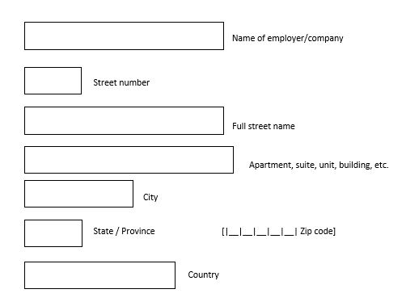

*NO RESPONSE à* ***GO TO CURWORK2***

**[IF RESPONDENT LEAVES ALL FIELDS BLANK IN CURWORK1, PROMPT WITH BELOW. IF RESPONDENT LEAVES CITY, STATE, ZIP, OR COUNTRY BLANK IN CURWORK1, PROMPT WITH BELOW.]**

**[NOTE FOR PROGRAMMERS: ONLY FIELDS THAT WERE NOT ALREADY COMPLETED IN CURWORK1 SHOULD BE PRESENTED AS OPEN FIELDS. IF RESPONSE WAS ALREADY PROVIDED TO ANY OF THESE FIELDS IN CURWORK1, POPULATE THE FIELD(S) AS PROTECTED, SUMMARIZED INFORMATION IN CURWORK2]**

1. [CURWORK2] Please provide the following information:

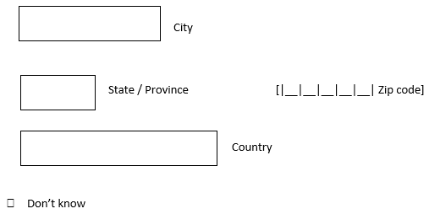

**[IF RESPONDENT LEAVES STREET NUMBER AND STREET NAME BLANK IN CURWORK1 BUT COMPLETED THE CITY, STATE, ZIP, AND/OR COUNTRY FIELDS IN CURWORK1 AND/OR CURWORK2, PROMPT WITH BELOW. IF ALL FIELDS LEFT BLANK IN CURWORK1 AND/OR CURWORK2, SKIP TO CURWORKCONFIRM.]**

1. [CURWORK3] Please provide the cross streets of the intersection closest to this address:



*NO RESPONSE à* ***GO TO CURWORKCONFIRM***

**[PIPED TEXT SHOULD INCLUDE ALL ADDRESS DETAILS THAT WERE PROVIDED. IF NO ADDRESS DETAILS WERE PROVIDED, FILL “this address”]**

1. [CURWORKCONFIRM] Here is the information you gave us for this location: [Insert address information from CURWORK1 – CURWORK3]

If this information is **not** correct, please click the “Back” button to edit your answers before moving on.

1. [CURWORKYR1] In what month and year did you **start** commuting to **[insert address from CURWORK1 – CURWORK3/this address]**?

[CURWORKYR1_Month] |__|__| Month [CURWORKYR1_Year] |__|__|__|__| Year

*NO RESPONSE à* ***GO TO CURWORKMOS***

1. [CURWORKMOS] How many **months of the year** did you commute to [insert address from CURWORK1 – CURWORK3/this address]?

|__|__| #Months

*NO RESPONSE à* ***GO TO CURWORKT1***

1. [CURWORKT1] What type(s) of transportation do you use to get to [insert address from CURWORK1 – CURWORK3/this address] from home? Select all that apply.

0 Car, van, or truck (includes carpools or van pools)

1 Taxicab (includes Uber, Lyft, or hired car)

2 Motorcycle

3 Bus or streetcar/trolley, light rail/trolley, light rail

4 Commuter rail, subway, metro

5 Bicycle

6 Walking

55 Other: Please describe [text box]

*NO RESPONSE* à ***GO TO CURWORKT6***

1. [CURWORKT2] Thinking about the **one-way trip** from your home to [insert address from CURWORK1 – CURWORK3/this address] on a usual workday, about how much time did you usually spend in each type of transportation?

|  |  |  |  |  |  |
| --- | --- | --- | --- | --- | --- |
| **[Display rows ONLY for responses marked in CURWORKT1]** | Less than 15 minutes | 15 to 29 minutes | 30 to 59 minutes | 1 to 2 hours | More than 2 hours |
| a. [CURWORKT2A] Car, van, or truck (includes carpools or van pools) | □ | □ | □ | □ | □ |
| b. [CURWORKT2B] Taxicab (includes, Uber, Lyft, or hired car) | □ | □ | □ | □ | □ |
| c. [CURWORKT2C] Motorcycle | □ | □ | □ | □ | □ |
| d. [CURWORKT2D] Bus or streetcar/trolley, light rail/trolley | □ | □ | □ | □ | □ |
| e. [CURWORKT2E] Commuter rail, subway, metro | □ | □ | □ | □ | □ |
| f. [CURWORKT2F] Bicycle | □ | □ | □ | □ | □ |
| g. [CURWORKT2G] Walking | □ | □ | □ | □ | □ |
| h. [CURWORKT2H] [OTHER FROM CURWORKT1] | □ | □ | □ | □ | □ |

*NO RESPONSE (ANY) à* ***GO TO CURWORKT6***

**[ASK CURWORKT3 – CURWORKT5 IF ANY CURWORKT2 = 1, 2, 3, OR 4]**

1. 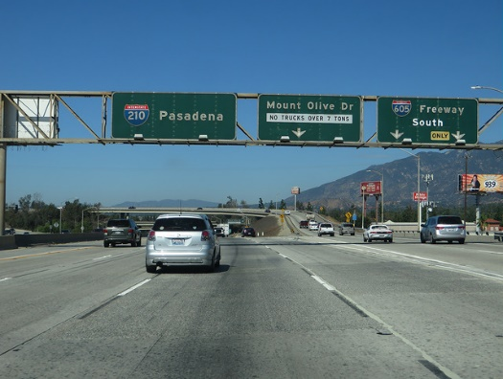[CURWORKT3] Did your usual one-way trip to [insert address from CURWORK1 – CURWORK3/this address] from your home involve travel on a highway, parkway, freeway, or toll road? An example is pictured.

0 Yes, for 15 minutes or more

1 Yes, for less than 15 minutes

2 No, not at all

*NO RESPONSE à* ***GO TO CURWORKT4***

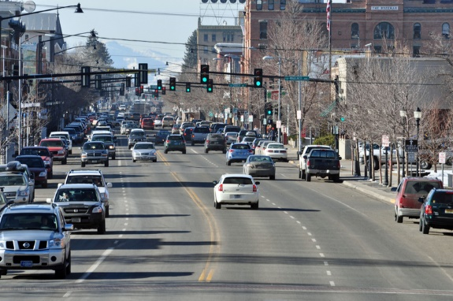

1. [CURWORKT4] Did your usual one-way trip to [insert address from CURWORK1 – CURWORK3/this address] from your homeinvolve travel on a major city or town roadway? These usually have two or more lanes and stoplights. An example is pictured.

0 Yes, for 15 minutes or more

1 Yes, for less than 15 minutes

2 No, not at all

*NO RESPONSE à* ***GO TO CURWORKT5***

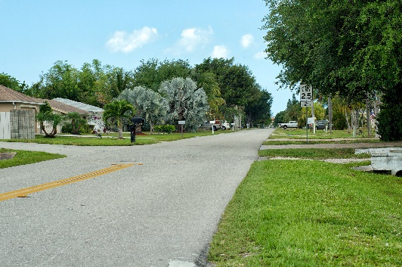

1. [CURWORKT5] Did your usual one-way trip to [insert address from CURWORK1 – CURWORK3/this address] from your homeinvolve travel on a local or neighborhood roadway? These usually have only one lane in each direction. An example is pictured.

0 Yes, for 15 minutes or more

1 Yes, for less than 15 minutes

2 No, not at all

*NO RESPONSE à* ***GO TO CURWORKT6***

1. [CURWORKT6] How many **days per week** did you usually make the trip from your home to [insert address from CURWORK1 – CURWORK3/this address]?

0 1 day per week

1 2 days per week

2 3 days per week

3 4 days per week

4 5 days per week

5 6 days per week

6 7 days per week

*NO RESPONSE* à ***GO TO CURWORKT7***

1. [CURWORKT7] To get home from [insert address from CURWORK1 – CURWORK3/this address], did you usually use thesame type(s) of transportation that you do to get to work from your home?

1 Yes

0 No à **GO TO CURWORKT9**

*NO RESPONSE à* ***GO TO CURWORKT9***

1. [CURWORKT8] Did the trip home usually take about the same amount of time as the trip to get to [insert address from CURWORK1 – CURWORK3/this address]?

1 Yes à **GO TO CURWORKT14**

0 No à **GO TO CURWORKT10**

*NO RESPONSE à* ***GO TO CURWORKT10***

1. [CURWORKT9] What type(s) of transportation did you use to get from [insert address from CURWORK1 – CURWORK3/this address] back to your home? Select all that apply.

0 Car, van, or truck (includes carpools or van pools)

1 Taxicab (includes Uber, Lyft, or hired car)

2 Motorcycle

3 Bus or streetcar/trolley, light rail/trolley

4 Commuter rail, subway, metro

5 Bicycle

6 Walking

55 Other: Please describe [text box]

*NO RESPONSE à* ***GO TO CURWORK14***

1. [CURWORKT10] Thinking about the **one-way trip** from [insert address from CURWORK1 – CURWORK3/this address] to your home on a usual workday, about how much time did you usually spend in each type of transportation?

**[IF CURWORKT7=NO or NR, then display rows ONLY for responses marked in CURWORKT9.**

**IF CURWORKT8=NO or NR, then also display responses marked in CURWORKT1.]**

|  |  |  |  |  |  |
| --- | --- | --- | --- | --- | --- |
|  | Less than 15 minutes | 15 to 29 minutes | 30 to 59 minutes | 1 to 2 hours | More than 2 hours |
| a. [CURWORKT10A] Car, van, or truck (includes carpools or van pools) | □ | □ | □ | □ | □ |
| b. [CURWORKT10B] Taxicab (includes, Uber, Lyft, or hired car) | □ | □ | □ | □ | □ |
| c. [CURWORKT10C] Motorcycle | □ | □ | □ | □ | □ |
| d. [CURWORKT10D] Bus or streetcar/trolley, light rail/trolley | □ | □ | □ | □ | □ |
| e. [CURWORKT10E] Commuter rail, subway, metro | □ | □ | □ | □ | □ |
| f. [CURWORKT10F] Bicycle | □ | □ | □ | □ | □ |
| g. [CURWORKT10G] Walking | □ | □ | □ | □ | □ |
| h. [CURWORKT10H] [OTHER FROM CURWORKT9 or CURWORKT2] | □ | □ | □ | □ | □ |

*NO RESPONSE (ANY) à* ***GO TO CURWORKT14***

**[ASK CURWORKT11 – CURWORKT13 IF ANY CURWORKT10 = 1, 2, 3, OR 4]**

1. 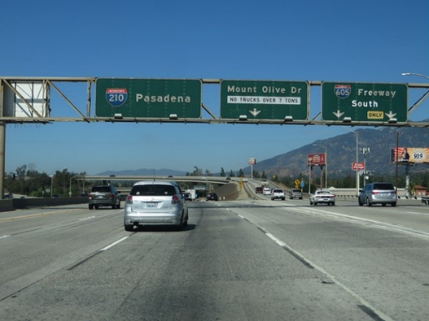[CURWORKT11] Did your usual one-way trip from [insert address from CURWORK1 – CURWORK3/this address] to your home involve travel on a highway, parkway, freeway, or toll road? An example is pictured.

0 Yes, for 15 minutes or more

1 Yes, for less than 15 minutes

2 No, not at all

*NO RESPONSE à* ***GO TO CURWORKT12***

1. 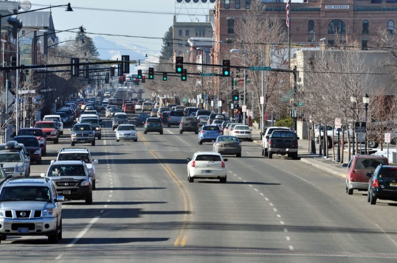 [CURWORKT12] Did your usual one-way trip from [insert address from CURWORK1 – CURWORK3/this address] to your home involve travel on a major city or town roadway? These usually have two or more lanes and stoplights. An example is pictured.

0 Yes, for 15 minutes or more

1 Yes, for less than 15 minutes

2 No, not at all

*NO RESPONSE à* ***GO TO CURWORKT13***

1. 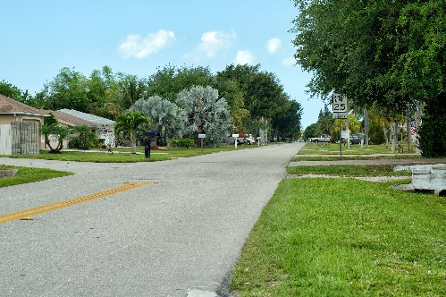[CURWORKT13] Did your usual one-way trip from [insert address from CURWORK1 – CURWORK3/this address] to your home involve travel on a local or neighborhood roadway? These usually have only one lane in each direction. An example is pictured.

0 Yes, for 15 minutes or more

1 Yes, for less than 15 minutes

2 No, not at all

*NO RESPONSE à* ***GO TO CURWORKT14***

1. [CURWORKT14] How many **days per week** did you usually make the trip back to your home from [insert address from CURWORK1 – CURWORK3/this address]?

0 1 day per week

1 2 days per week

2 3 days per week

3 4 days per week

4 5 days per week

5 6 days per week

6 7 days per week

*NO RESPONSE à* ***GO TO PREWORK***

**Work Commutes in the Past**

1. [PREWORK] In the **past 20 years**, did you commute from your home to a job a**t least once a week for at least one year**?

1 Yes

0 No **--> GO TO INTROCURSCH**

*NO RESPONSE à* ***GO TO INTROCURSCH***

1. [PREWORKRES] Thinking of your longest held occupation, did your daily responsibilities involve driving (such as a sales representative, courier, bus driver, or truck driver)?

1 Yes **--> GO TO INTROCURSCH**

0 No

*NO RESPONSE* ***--> GO TO INTROPREWORK***

[INTROPREWORK] The next questions are about the place where you worked for the longest time **in** the **past 20 years**, and your commute between the place where you worked and home.

[PREWORK1A] Is your current job the longest job you have had in the past 20 years?

1 Yes **--> GO TO INTROCURSH**

0 No, I worked longer at another job that I had within the past 20 years **--> GO TO**  **PREWORK1B**

1. [PREWORK1B] Thinking about the job you had the longest in the **past 20 years**, what was the name and the street address of the workplace you commuted to most often?



*NO RESPONSE à* ***GO TO PREWORK2***

**[IF RESPONDENT LEAVES ALL FIELDS BLANK IN PREWORK1B, PROMPT WITH BELOW. IF RESPONDENT LEAVES CITY, STATE, ZIP, OR COUNTRY BLANK IN PREWORK1B, PROMPT WITH BELOW.]**

**[NOTE FOR PROGRAMMERS: ONLY FIELDS THAT WERE NOT ALREADY COMPLETED IN PREWORK1B SHOULD BE PRESENTED AS OPEN FIELDS. IF RESPONSE WAS ALREADY PROVIDED TO ANY OF THESE FIELDS IN PREWORK1B, POPULATE THE FIELD(S) AS PROTECTED, SUMMARIZED INFORMATION IN PREWORK2]**

1. [PREWORK2] Please provide the following information:



**[IF RESPONDENT LEAVES STREET NUMBER AND STREET NAME BLANK IN PREWORK1B BUT COMPLETED THE CITY, STATE, ZIP, AND/OR COUNTRY FIELDS IN PREWORK1B AND/OR PREWORK2, PROMPT WITH BELOW. IF ALL FIELDS LEFT BLANK IN PREWORK1 AND/OR PREWORK2, SKIP TO PREWORKCONFIRM.]**

1. [PREWORK3] Please provide the cross streets of the intersection closest to this address:



*NO RESPONSE à* ***GO TO PREWORKCONFIRM***

**[PIPED TEXT SHOULD INCLUDE ALL ADDRESS DETAILS THAT WERE PROVIDED. IF NO ADDRESS DETAILS WERE PROVIDED, FILL “this address”]**

1. [PREWORKCONFIRM] Here is the information you gave us for this location: [Insert address information from PREWORK1B – PREWORK3]

If this information is **not** correct, please click the “Back” button to edit your answers before moving on.

1. [PREWORKYR1] What year did you **start** commuting to **[insert address from PREWORK1B – PREWORK3/this address]?**

|__|__|__|__| Year started commuting to this address

*NO RESPONSE à* ***GO TO PREWORKYR2***

1. [PREWORKYR2] What year did you **last** commute to [PREWORK1B – PREWORK3/this address]?

|__|__|__|__| Year stopped commuting to this address

*NO RESPONSE à* ***GO TO PREWORKT1***

1. [PREWORKT1] What type(s) of transportation did youuse to get from your home to [insert address from PREWORK1B – PREWORK3/this address]? Select all that apply.

0 Car, van, or truck (includes carpools or van pools)

1 Taxicab (includes Uber, Lyft, or hired car)

2 Motorcycle

3 Bus or streetcar/trolley, light rail/trolley

4 Commuter rail, subway, metro

5 Bicycle

6 Walking

55 Other: Please describe [text box]

*NO RESPONSE à* ***GO TO PREWORKT3***

*[Informational text if “type(s) of transportation” is selected:* If you changed the type of transportation that you used during the time that you commuted to this place of work, answer based on the type(s) of transportation you used most often.]

1. [PREWORKT2] Thinking about the **one-way** trip from your home to [insert address from PREWORK1B – PREWORK3/this address] on a usual workday, about how much time did you usuallyspend in each type of transportation?

|  |  |  |  |  |  |
| --- | --- | --- | --- | --- | --- |
| **[Display rows ONLY for responses marked in PREWORKT1]** | Less than 15 minutes | 15 to 29 minutes | 30 to 59 minutes | 1 to 2 hours | More than 2 hours |
| a. [PREWORKT2A] Car, van, or truck (includes carpools or van pools) | □ | □ | □ | □ | □ |
| b. [PREWORKT2B] Taxicab (includes, Uber, Lyft, or hired car) | □ | □ | □ | □ | □ |
| c. [PREWORKT2C] Motorcycle | □ | □ | □ | □ | □ |
| d. [PREWORKT2D] Bus or streetcar/trolley, light rail/trolley | □ | □ | □ | □ | □ |
| e. [PREWORKT2E] Commuter rail, subway, metro | □ | □ | □ | □ | □ |
| f. [PREWORKT2F] Bicycle | □ | □ | □ | □ | □ |
| g. [PREWORKT2G] Walking | □ | □ | □ | □ | □ |
| h. [PREWORKT2H] [*OTHER FROM PREWORKT1*] | □ | □ | □ | □ | □ |

*NO RESPONSE (ANY) à* ***GO TO PREWORKT3***

1. [PREWORKT3] How many **days per week** did you usually make the trip from your home to [insert address from PREWORK1 – PREWORK3/this address]?

0 1 day per week

1 2 days per week

2 3 days per week

3 4 days per week

4 5 days per week

5 6 days per week

6 7 days per week

*NO RESPONSE à* ***GO TO PREWORKT4***

1. [PREWORKT4] To get home from work, did you usuallyuse the same type(s)of transportation as you did to get to [insert address from PREWORK1B – PREWORK3/this address]from your home?

1 Yes

0 No à **PREWORKT6**

*NO RESPONSE à* ***GO TO PREWORKT6***

1. [PREWORKT5] Did the trip home usually take about the same amount of time as the trip to get to [insert address from PREWORK1B – PREWORK3/this address] from your home?

1 Yes à **GO TO PREWORKT8**

0 No à **GO TO PREWORKT7**

*NO RESPONSE à* ***GO TO PREWORKT7***

1. [PREWORKT6] What type(s) of transportation did you use to get from [insert address from PREWORK1B – PREWORK3/this address] back home? Select all that apply.

0 Car, van, or truck (includes carpools or van pools)

1 Taxicab (includes Uber, Lyft, or hired car,)

2 Motorcycle

3 Bus or streetcar/trolley, light rail/trolley

4 Commuter rail, subway, metro

5 Bicycle

6 Walking

55 Other: Please describe [text box]

*NO RESPONSE à* ***GO TO PREWORKT8***

1. [PREWORKT7] Thinking about the **one-way** trip from [insert address from PREWORK1B – PREWORK3/this address] to your homeon a usual workday, about how much time did you usually **s**pend in each type of transportation?

**[IF PREWORKT4=NO, then display rows ONLY for responses marked in PREWORKT6.**

**IF PREWORKT5=NO, then also display responses marked in PREWORKT1.]**

|  |  |  |  |  |  |
| --- | --- | --- | --- | --- | --- |
|  | Less than 15 minutes | 15 to 29 minutes | 30 to 59 minutes | 1 to 2 hours | More than 2 hours |
| a. [PREWORKT7A] Car, van, or truck (includes carpools or van pools) | □ | □ | □ | □ | □ |
| b. [PREWORKT7B] Taxicab (includes, Uber, Lyft, or hired car) | □ | □ | □ | □ | □ |
| c. [PREWORKT7C] Motorcycle | □ | □ | □ | □ | □ |
| d. [PREWORKT7D] Bus or streetcar/trolley, light rail/trolley | □ | □ | □ | □ | □ |
| e. [PREWORKT7E] Commuter rail, subway, metro | □ | □ | □ | □ | □ |
| f. [PREWORKT7F] Bicycle | □ | □ | □ | □ | □ |
| g. [PREWORKT7G] Walking | □ | □ | □ | □ | □ |
| h. [PREWORKT7H] [OTHER FROM PREWORKT6 OR PREWORKT1] | □ | □ | □ | □ | □ |

*NO RESPONSE (ANY) à* ***GO TO PREWORKT8***

1. [PREWORKT8] How many **days per week** did you usually make the trip back to your home from [insert address from PREWORK1B – PREWORK3/this address]?

0 1 day per week

1 2 days per week

2 3 days per week

3 4 days per week

4 5 days per week

5 6 days per week

6 7 days per week

*NO RESPONSE à* ***GO TO INTROCURSCH***

**Current School Commute**

IF STUDENT= 1 OR 2 à **CONTINUE TO INTROCURSCH**

IF STUDENT = 0 à **GO TO END OF MODULE**

[INTROCURSCH] Earlier, you said that you are currently enrolled in school. The next questions are about the place where you currentlyattend school and your commute from home to this location.

1. [CURSCHCOM] Do you commute from your home to your current school at least once a week?

1 Yes

0 No à **GO TO END OF MODULE**

*NO RESPONSE à* ***GO TO END OF MODULE***

1. [CURSCHCOM2] In a **usual week**, to how many different schools or campuses do you commute to?

0 One

1 More than one

*NO RESPONSE à* ***GO TO CURSCH1***

1. [CURSCH1] What is the name and the street address of the school that you commute to most often?

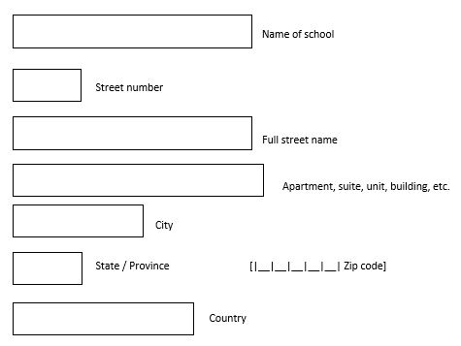

*NO RESPONSE à* ***GO TO CURSCH2***

**[IF RESPONDENT LEAVES ALL FIELDS BLANK IN CURSCH1, PROMPT WITH BELOW. IF RESPONDENT LEAVES CITY, STATE, ZIP, OR COUNTRY BLANK IN CURSCH1, PROMPT WITH BELOW.]**

**[NOTE FOR PROGRAMMERS: ONLY FIELDS THAT WERE NOT ALREADY COMPLETED IN CURSCH1 SHOULD BE PRESENTED AS OPEN FIELDS. IF RESPONSE WAS ALREADY PROVIDED TO ANY OF THESE FIELDS IN CURSCH1, POPULATE THE FIELD(S) AS PROTECTED, SUMMARIZED INFORMATION IN CURSCH2]**

1. [CURSCH2] Please provide the following information:



**[IF RESPONDENT LEAVES STREET NUMBER AND STREET NAME BLANK IN CURSCH1 BUT COMPLETED THE CITY, STATE, ZIP, AND/OR COUNTRY FIELDS IN CURSCH1 AND/OR CURSCH2, PROMPT WITH BELOW. IF ALL FIELDS LEFT BLANK IN CURSCH1 AND CURSCH2, SKIP TO CURSCHCONFIRM.]**

1. [CURSCH3] Please provide the cross streets of the intersection closest to this address:



*NO RESPONSE à* ***GO TO CURSCHCONFIRM***

**[PIPED TEXT SHOULD INCLUDE ALL ADDRESS DETAILS THAT WERE PROVIDED. IF NO ADDRESS DETAILS WERE PROVIDED, FILL “this address”]**

1. [CURSCHCONFIRM] Here is the information you gave us for this location: [Insert address information from CURSCH1 – CURSCH3]

If this information is **not** correct, please click the “Back” button to edit your answers before moving on.

1. [CURSCHYR1] In what **month and year** did you **start** commuting to **[insert address from CURSCH1 – CURSCH3/this address]?**

[CURSCHYR1] |__|__| Month [CURSCHYR2] |__|__|__|__| Year

*NO RESPONSE à* ***GO TO CURSCHMOS***

1. [CURSCHMOS] How many of the **past 12 months** did you commute to [insert address from CURSCH1 – CURSCH3/this address] from your home?

[CURSCHMOS] |__|__| #Months

*NO RESPONSE à* ***GO TO CURSCHT1***

1. [CURSCHT1] What type(s) of transportation do you use to get from your home to [insert address from CURSCH1 – CURSCH3/this address]? Select all that apply.

0 Car, van, or truck (includes carpools or van pools)

1 Taxicab (includes Uber, Lyft, or hired car)

2 Motorcycle

3 Bus or streetcar/trolley, light rail/trolley

4 Commuter rail, subway, metro

5 Bicycle

6 Walking

55 Other: Please describe [text box]

*NO RESPONSE à* ***GO TO CURSCHT6***

1. [CURSCHT2] Thinking about the **one-way** trip from your home to [insert address from CURSCH1 – CURSCH3/this address] on a usual day, about how much timedo you usually spend in each type of transportation?

|  |  |  |  |  |  |
| --- | --- | --- | --- | --- | --- |
| **[Display rows ONLY for responses marked in CURSCHT1]** | Less than 15 minutes | 15 to 29 minutes | 30 to 59 minutes | 1 to 2 hours | More than 2 hours |
| a. [CURSCHT2A] Car, van, or truck (includes carpools or van pools) | □ | □ | □ | □ | □ |
| b. [CURSCHT2B] Taxicab (includes, Uber, Lyft, or hired car) | □ | □ | □ | □ | □ |
| c. [CURSCHT2C] Motorcycle | □ | □ | □ | □ | □ |
| d. [CURSCHT2D] Bus or streetcar/trolley, light rail/trolley | □ | □ | □ | □ | □ |
| e. [CURSCHT2E] Commuter rail, subway, metro | □ | □ | □ | □ | □ |
| f. [CURSCHT2F] Bicycle | □ | □ | □ | □ | □ |
| g. [CURSCHT2G] Walking | □ | □ | □ | □ | □ |
| h. [CURSCHT2H] [OTHER FROM CURSCHT1] | □ | □ | □ | □ | □ |

*NO RESPONSE (ANY) à* ***GO TO CURSCHT6***

**[ASK CURSCHT3 – CURSCHT5 IF ANY CURSCHT2 = 1, 2, 3, OR 4]**

1. 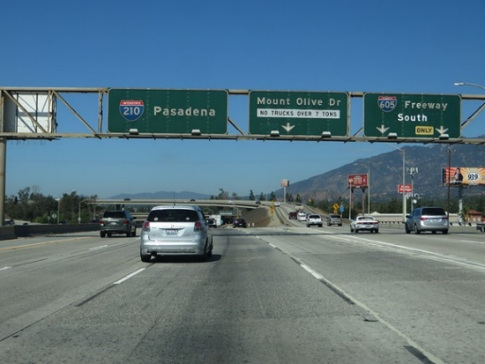[CURSCHT3] Does your usual one-way trip to[insert address from CURSCH1 – CURSCH3/this address] from your home involve travel on a highway, parkway, freeway, or toll road? An example is pictured.

0 Yes, for 15 minutes or more

1 Yes, for less than 15 minutes

2 No, not at all

*NO RESPONSE à* ***GO TO CURSCHT4***

1. 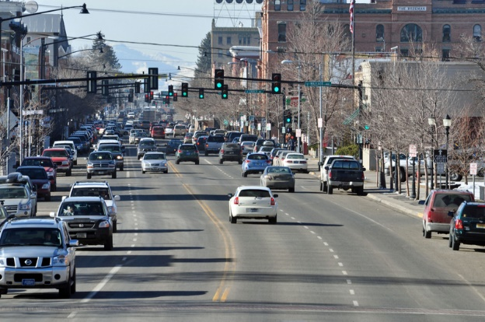 [CURSCHT4] Does your usual one-way trip to[insert address from CURSCH1 – CURSCH3/this address] from your home involve travel on a major city or town roadway? These usually have two or more lanes and stoplights. An example is pictured.

0 Yes, for 15 minutes or more

1 Yes, for less than 15 minutes

2 No, not at all

*NO RESPONSE à* ***GO TO CURSCHT5***

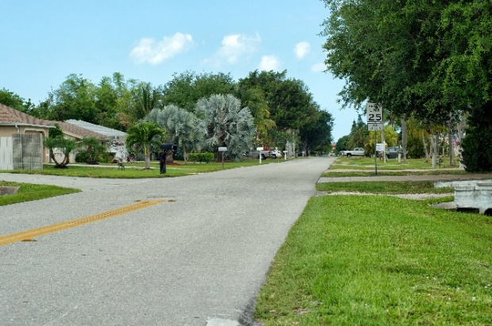

1. [CURSCHT5] Does your usual one-way trip to[insert address from CURSCH1 – CURSCH3/this address] from your home involve travel on a local or neighborhood roadway? These usually have only one lane in each direction. An example is pictured.

0 Yes, for 15 minutes or more

1 Yes, for less than 15 minutes

2 No, not at all

*NO RESPONSE à* ***GO TO CURSCHT6***

1. [CURSCHT6] How many **days per week** do you usually make the trip from your home to [insert address from CURSCH1 – CURSCH3/this address]?

0 1 day per week

1 2 days per week

2 3 days per week

3 4 days per week

4 5 days per week

5 6 days per week

6 7 days per week

*NO RESPONSE à* ***GO TO CURSCHT7***

1. [CURSCHT7] To get home from [insert address from CURSCH1 – CURSCH3/this address], do you usually use the same type(s) of transportation as you do to get to school from home?

1 Yes

0 No à **GO TO CURSCHT9**

*NO RESPONSE à* ***GO TO CURSCHT9***

1. [CURSCHT8] Does the trip home usually take about the same amount of time as the trip to get to [insert address from CURSCH1 – CURSCH3/this address] from your home?

1 Yes à **GO TO CURSCHT14**

0 No à **GO TO CURSCHT10**

*NO RESPONSE à* ***GO TO CURSCHT10***

1. [CURSCHT9] What type(s) of transportation do you use to get from [insert address from CURSCH1 – CURSCH3/this address] back home? Select all that apply.

0 Car, van, or truck (includes carpools or van pools)

1 Taxicab (includes Uber, Lyft, or hired car,)

2 Motorcycle

3 Bus or streetcar/trolley, light rail/trolley

4 Commuter rail, subway, metro

5 Bicycle

6 Walking

55 Other: Please describe [text box]

*NO RESPONSE à* ***GO TO CURSCHT14***

1. [CURSCHT10] Thinking about the **one-way** trip from [insert address from CURSCH1 - CURSCH3/this address] to your home on a usual day, about how much time do you usually spend in each type of transportation?

**[IF CURSCHT7=NO, then display rows ONLY for responses marked in CURSCHT9.**

**IF CURSCHT8=NO, then also display responses marked in CURSCHT1.]**

|  |  |  |  |  |  |
| --- | --- | --- | --- | --- | --- |
|  | Less than 15 minutes | 15 to 29 minutes | 30 to 59 minutes | 1 to 2 hours | More than 2 hours |
| a. [CURSCHT10A] Car, van, or truck (includes carpools or van pools) | □ | □ | □ | □ | □ |
| b. [CURSCHT10B] Taxicab (includes, Uber, Lyft, or hired car) | □ | □ | □ | □ | □ |
| c. [CURSCHT10C] Motorcycle | □ | □ | □ | □ | □ |
| d. [CURSCHT10D] Bus or streetcar/trolley, light rail/trolley | □ | □ | □ | □ | □ |
| e. [CURSCHT10E] Commuter rail, subway, metro | □ | □ | □ | □ | □ |
| f. [CURSCHT10F] Bicycle | □ | □ | □ | □ | □ |
| g. [CURSCHT10G] Walking | □ | □ | □ | □ | □ |
| h. [CURSCHT10H] [OTHER FROM CURSCHT9 or CURSCHT1] | □ | □ | □ | □ | □ |

*NO RESPONSE (ANY) à* ***GO TO CURSCHT14***

**[ASK CURSCHT11 – CURSCHT13 IF ANY CURSCHT10 = 1, 2, 3, OR 4]**

1. 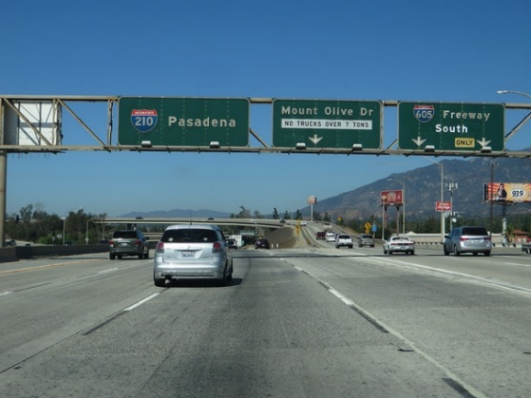[CURSCHT11] Does your usual one-way trip from[insert address from CURSCH1 – CURSCH3/this address] to your home involve travel on a highway, parkway, freeway, or toll road? An example is pictured.

0 Yes, for 15 minutes or more each way

1 Yes, for less than 15 minutes each way

2 No, not at all

*NO RESPONSE* *à* ***GO TO CURSCHT12***

1.  [CURSCHT12] Does your usual one-way trip from[insert address from CURSCH1 – CURSCH3/this address] to your home involve travel on a major city or town roadway? These usually have two or more lanes and stoplights. An example is pictured.

0 Yes, for 15 minutes or more

1 Yes, for less than 15 minutes

2 No, not at all

*NO RESPONSE* *à* ***GO TO CURSCHT13***

1. 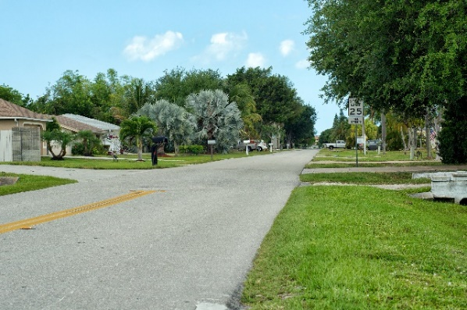[CURSCHT13] Does your usual one-way trip from[insert address from CURSCH1 – CURSCH3/this address]to your home involve travel on a local or neighborhood roadway? These usually have only one lane in each direction. An example is pictured.

0 Yes, for 15 minutes or more

1 Yes, for less than 15 minutes

2 No, not at all

*NO RESPONSE* *à* ***GO TO CURSCHT14***

1. [CURSCHT14] How many **days per week** do you usually make the trip back to your home from [insert address from CURSCH1 – CURSCH3/this address]?

0 1 day per week

1 2 days per week

2 3 days per week

3 4 days per week

4 5 days per week

5 6 days per week

6 7 days per week

*NO RESPONSE* *à* ***GO TO END OF MODULE***

**END OF MODULE**

**Closing remark on submit survey screen: “You have answered all of the questions in this survey. To submit your answers, select the “Submit Survey” button.”**